Self-Ligating Bracket System
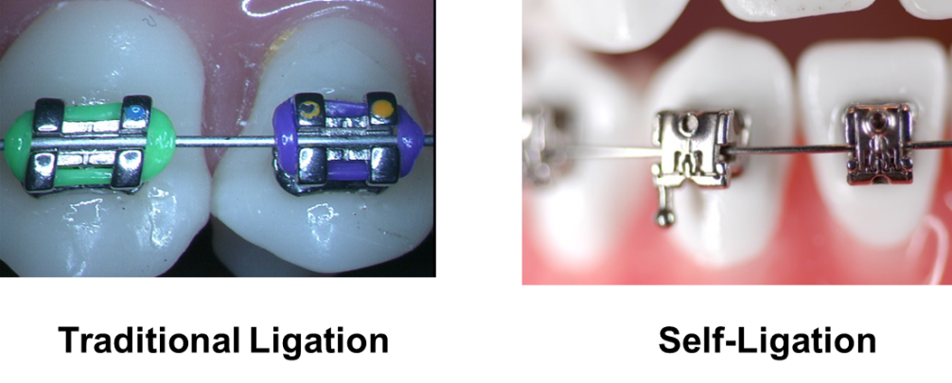
- 了解Active and Passive Bracket
Active: the bracket has a sliding spring clip potentially placing an active force on the archwire (Speed, Time, and In-Ovation).
Passive: the bracket has a sliding door with no intention or ability to invade the slot.
- A.J.O.的報告
Forces released during sliding mechanics
with passive self-ligating brackets or
nonconventional elastomeric ligatures
Am J Orthod Dentofacial Orthop 2008;133:87-90
CONCLUSIONS
PASSIVE SLB’s and NON CONVENTIONAL ELAST. LIG. Brackets,
produce significantly smaller frictional forces
(below 2 g.)
CONVENTIONAL ELASTOMERIC LIGATURE Brackets, produce high
frictional forces (above 500 g.)
- 了解矯正裝置所產生的磨擦力
Primary type of friction - created in the bracket wire interface.
Secondary type of friction - produced by the sliding friction against each other’s
interdental contact points which behave as inclined planes. This is present in
the direct expansion of crowded dental arches.
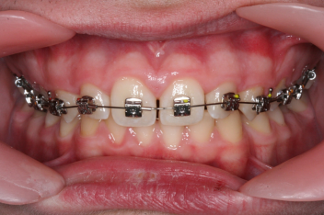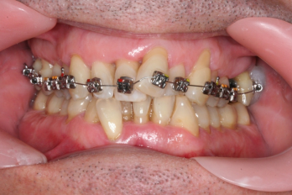
Primary type of friction Secondary Type of Friction

- 早在1953年 知名矯正學者Moyers就提出了矯正的適當力量
Selection of forces for tooth movement:
A summary of our present knowledge.
Halderson H, Johns EE, Moyers RE.
Am J Orthod 1953;39:25-35
The most adequate force to move teeth is close to the pressure of blood,
inside capillary vessels of the periodontal membrane. This is equivalent to
20 to 26 gr. of pressure per square centimetre.

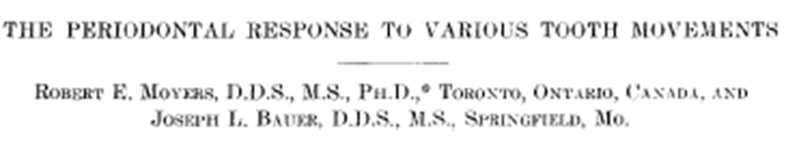
Force applied with traditional edgewise brackets, tied to the archwire with active
ligatures, promote the presence of necrosis in the periodontal area of pressure.
- 臨床考量
Periodontal structures will react better to reduced forces; those less than 26 grams
of force.
- Wire sequence
Distalizer 10 weeks (if need)
.014 Thermal 10 weeks
.014x.025 Thermal 8 weeks
.017x.025 Thermal 8 weeks
.019x.025 Thermal 8 weeks
.019x.025 S.S. 10 weeks
Total 13 ½ months

